Mall Customer Segmentation

By Rohit Shah

.1 Problem Statement



Customer Segmentation is a popular application of unsupervised learning. Using clustering, identify

segments of customers to target the potential user base. They divide customers into groups

according to common characteristics like gender, age, interests, and spending habits so they can

market to each group effectively.

Use K-means clustering and also visualize the gender and age distributions. Then analyze their annual

incomes and spending scores.

## Introduction to Problem Statement

To make predictions and find the clusters of potential customers of the mall and thus find appropriate measures to increase the revenue of the mall is one of the prevailing applications of unsupervised learning.

For example, a group of customers have high income but their spending score (amount spent in the mall) is low so from the analysis we can convert such type of customers into potential customers (whose spending score is high) by using strategies like better advertising, accepting feedback and improving the quality of products.



To identify such customers, this project analyses and forms clusters based on different criteria which are discussed in the further sections.

# Dataset

Overview of Dataset

The dataset name is *Mall_Customers.csv* consists of 5 columns which are CustomerID, Gender, Age, Annual Income

(k$), Spending Score (1-100) where Gender is a categorical value and rest all features are numeric.

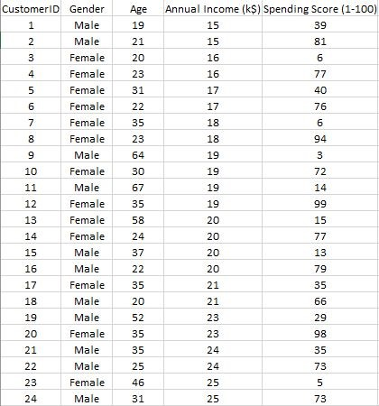

The size of the dataset is (200, 5) which is 200 rows and 5 columns.

# Proposed Method & Architecture

3.1 Architecture Overview

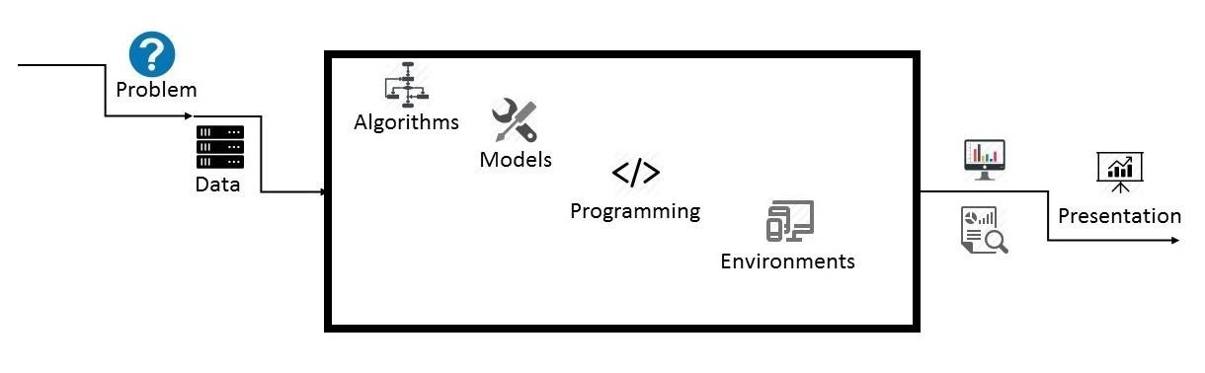

*3.1*

*Data Science Project Architecture*

3.2 Project Architecture



***Data:***

The size of the dataset is (200, 5) which is 200 rows and 5 columns. Also on dataset does not contain

any NULL or NaN values.

***Algorithms:***

K-means algorithm is used in this project to analyze and form clusters of customers based on

their income and spending score features.

***Model:***

K-means model is used and is hyper tuned parameters like n_clusters=5 using elbow method to find

the optimal number of clusters also init=’k-means++’ to avoid random initialization trap.

***Programming Language:***

Python 3.6

***Environment (Libraries and Technologies):***

Numpy, Pandas, Matplotlib, Seaborn, Jupyter Notebook, Google

Colab.

# Methodology

Methodology



●

Creating an approach to solve the given problem statement

●

Exploring the dataset and obtaining useful insight from the same

●

Cleaning the dataset by handling nan values, remove duplicate records, etc.

●

Data Visualization used to obtain important information from the data

●

Data Preprocessing is performed to make the data ready to fit the model this includes feature

scaling, splitting the dataset into features and labels, etc.

●

Model Building

# Implementation and Analysis

5.1 Gender Plot

*Gender Plot Analysis:*

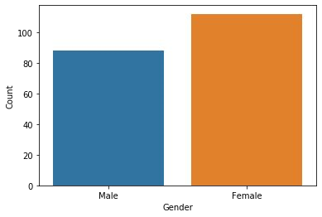

From the Count plot, it is observed that the number of Female customers is more than the total number of Male customers.

5.2 Age Plot

*Age Plot Analysis:*

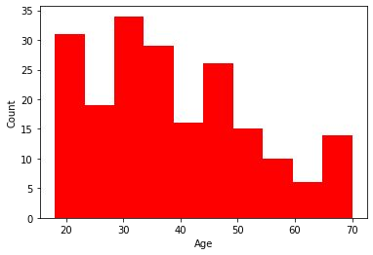

From the Histogram it is evident that there are 3 age groups that are more frequently shop at the mall, they are:

15-22 years, 30-40 years, and 45-50 years.

5.3 Age Vs Spending Score

*Age Vs Spending Score Analysis*

1. From the Age Vs Spending Score plot we observe that customers whose spending score is more than 65 have their Age in the range of 15-42 years. Also from the Scatter plot it is observed that customers whose spending score is more than 65 consists of more Females than Males.

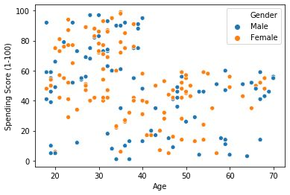

1. The customers having average spending score ie: in the range of 40-60 consists of the age group of the range 15-75 years and the count of males and females in this age group is also approximately the same.

5.4 Annual Income Vs Spending Score

*Annual Income Vs Spending Score Analysis*

We observe that there are 5 clusters and can be categorized as:

1. High Income, High Spending Score *(Top*

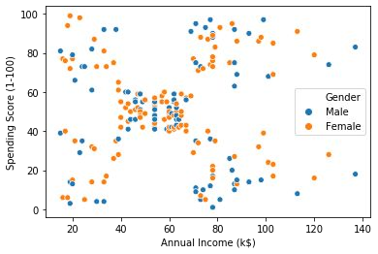

*Right Cluster)*

1. High Income, Low Spending Score

*(Bottom Right Cluster)*

1. Average Income, Average Spending Score

*(Center Cluster)*

1. Low Income, High Spending Score *(Top*

*Left Cluster)*

1. Low Income, Low Spending Score

*(Bottom Left Cluster)*

# Conclusion

Clustering Analysis

1. *High Income, High Spending Score (Cluster 5) - Target these customers by sending new product alerts which would lead to an increase in the revenue collected by the mall as they are loyal customers.*
2. *High Income, Low Spending Score (Cluster 2) - Target these customers by asking the feedback and advertising the product in a better sway to convert them into Cluster 5 customers.*

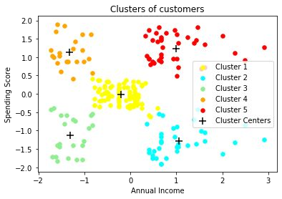

1. *Average Income, Average Spending Score (Cluster 1) - May or may not target these groups of customers based on the policy of the mall.*
2. *Low Income, High Spending Score (Cluster 4) - Can target these set of customers by providing them with Low-cost EMI's, etc.*
3. *Low Income, Low Spending Score (Cluster 3) - Don't target these customers since they have less income and need to save money.*

Thankyou!

Contact Me:

Email:shahrohit2109@gmail.com